MARTIN McDONAGH
THE PILLOWMAN

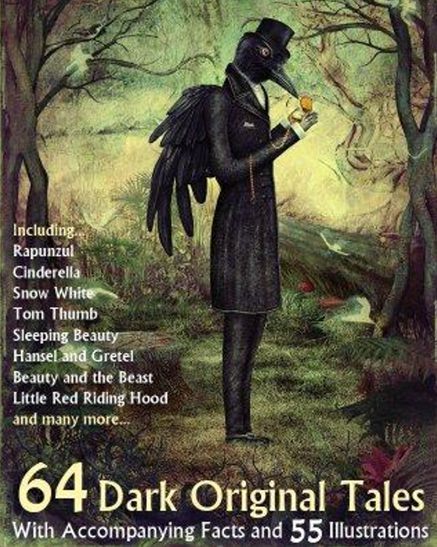

A writer in a totalitarian state is interrogated about the gruesome content of his short stories and their similarities to a number of child-murders that are happening in his town.

Director
Simon Futty

Performance Dates | Tuesday 28 February – Saturday 4 March 2023  N.B. There will be a matinee on the Saturday
Performance Venue | Seligman Theatre, Chapter
Rehearsal Dates | Throughout December, January & February  - Exact nights TBC; two weeknights and one full weekend day  Get-in: Sunday 26 February  Dress rehearsal: Monday 27 February
Auditions | Everyman Clubroom, Chapter  FRIDAY 4TH NOVEMBER  The Interrogation, 18:00 – 20.00  The Stories, 20.00 – 22.00  SATURDAY 5TH NOVEMBER  The Interrogation, 10:00 – 13:00  The Stories, 14:00 – 17:00  FRIDAY 11TH NOVEMBER  The Interrogation, 18:00 – 20.00  The Stories, 20.00 – 22.00  SATURDAY 12TH NOVEMBER  Callbacks tba.
Book your audition: | CONTACT EVERYMAN  Email: auditions@everymantheatre.co.uk  Please state your preferred audition date. You are very welcome to audition for both “worlds” of the play if you wish to, though be aware that you will be required to attend two separate audition slots to do so.
Preparation: | Please include as much information as possible on the accompanying form and send it when booking your audition.  You do not need to prepare anything in advance. Auditions will take the form of workshops and reading scenes from the script, handed to you at the audition.

DIRECTOR’S NOTES

- Background to the play/themes

The Pillowman was performed to great acclaim at the National Theatre in 2003 and starred David Tennant and Jim Broadbent. It subsequently opened on Broadway and starred Billy Crudup and Jeff Goldblum. The tone, throughout, is darkly comic. It slides between the very real world of a terrifying police interrogation in an unnamed totalitarian state and the fantasy world of Grimm-style fairy tale. McDonagh is known for his dark stage comedies such The Lieutenant of Inishmore or Hangmen. His film work includes writing and directing In Bruges and writing the screen play for Three Billboards Outside Ebbing Missouri for which he won an Oscar. He has recently returned to his Irish roots by writing and directing The Banshees of Inisherin.

- Synopsis

The play divides into two worlds:

World One – ‘the real world’ is an interrogation. A children’s author, Katurian is being interrogated by secret policemen in an interview room in an unnamed Eastern European totalitarian state. They tell him they will execute him that night but in Kafkaesque tradition are not letting him know precisely why he has been arrested. We eventually discover that there have been a number of copycat murders which seem to be based on his macabre stories.

World Two - ‘the tales’ features Katurian’s children’s tales as twisted or disturbing as anything from an original Brothers Grimm.

The tales consist of:

The Apple Men – a gruesome tale of a small girl’s revenge on her abusive father by secreting razor blades in apples she instructs him not to eat. However, the Apple Men take a terrifying counter-revenge.

The Three Gibbet Crossroads – a Kafkaesque tale of a man in a gibbet at a crossroads ignorant of his crime and unable to see the sign over his own cage. He asks many others – other condemned prisoners, townsfolk, nuns and a highwayman but all refuse – his crime is too terrible – and he dies in ignorance of what he been accused of doing.

The Pied Piper (Katurian version) – A small boy by a river come across the Pied Piper introducing the rats into Hamelin. The whole thing is a set-up, the Pied Piper wants access to the children.

The Writer and the Writer’s brother – a dark autobiographical tale of Katurian’s childhood featuring the relationship with his brother, Michal.

The Pillowman – a character as iconic as The Sandman or The Krampus, The Pillowman visits people on the brink of ending it all, then journeys back though time to persuade their younger selves to commit suicide then and there, thus sparing themselves a lifetime of misery.

The story is reprised in the epilogue.

The Little Pig – About a green pig isolated and mocked by his pink peers.

The Little Jesus – About a foul-mouthed girl who thought she was Jesus and who finally gets her dearest wish granted: to be crucified.

The Story of the Little Deaf Boy on the Long Railroad Tracks. In China – This is not part of the storytelling ensemble but comprises a very badly-told story by Tupolski.

Concept

The play can be performed with a cast of 6-9 but I would like to open up the storytelling parts to a larger ensemble cast. They would share narration and create the world of the stories through a variety of techniques: silent acting, tableaux, puppetry, shadow-play and shadow-puppetry.

CHARACTER BREAKDOWN

In The Real World…

TUPOLSKI (M or F, 30+) Detective. Very sardonic, similar to one from a 70s cop show. Utterly brutal but enjoys playing “good cop”.

KATURIAN (M, 30+) The writer. Disorientated by his arrest and, at first, very compliant, but becomes stronger though the piece. Needs to be able to tell a good story.

ARIEL (M, 20s/30s) Violent and sadistic cop. Enjoys playing “bad cop” but in fact with a strange and very correct sense of right and wrong.

MICHAL (M, 30+) Katurian’s older brother but with the mind of a child. Capable of a chilling detached violence.

In The Tales…

The list is not definitive. It is also worth noting that there are clear parallels with parental figures, authority figures, evil figures, vulnerable boys and strong-willed girls, so a good opportunity for doubling.

Apple Girl
Her Father
Criminal in Gibbet
Dying Man
Townsfolk
Highwayman
The Lame Boy
Pied Piper
Father/Mother to Writer and his Brother
Writer’s Brother aged 8
Girl Who Thought She Was Jesus
Her Parents / Evil Foster Parents
Priest
Blind Man

